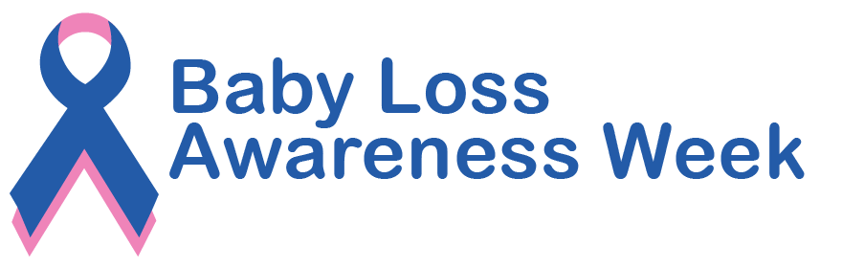

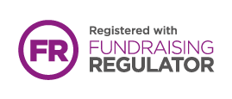

Together we can support bereaved families and save babies’ lives.

Sands. Charity Registered in Scotland SC042789, England and Wales 299679. We also operate in Northern Ireland. Company Limited by Guarantee Number: 2212082. Registered Address: 10–18 Union Street, London, SE1 1SZ.
sands.org.uk
Help Sands save babies’ lives and support anyone
affected by pregnancy loss or the death of a baby.

